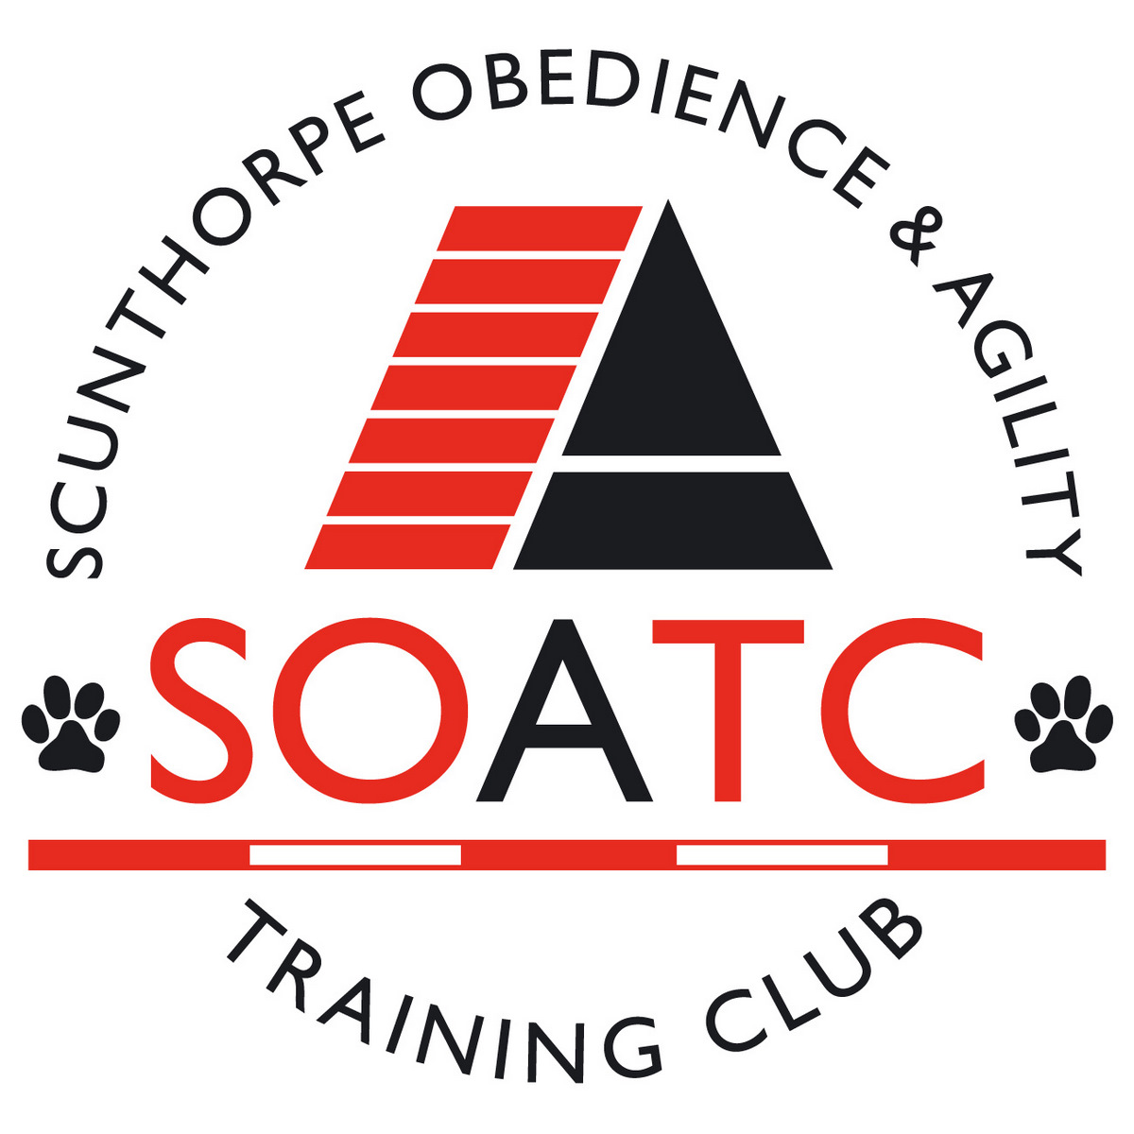 | SCUNTHORPE  OBEDIENCE & AGILITY  TRAINING CLUB

BLOCK CAPITALS PLEASE
SURNAME:-
FORENAMES:-
ADDRESS:-
Email address
POSTCODE:- |  |  | TELEPHONE:-
BREED OF DOGS:-
NAME OF DOGS:-
FEES:

OBEDIENCE: INCLUDING ONE YEAR MEMBERSHIP:
Initial 6 week course - £25.00 per person/dog
Additional 6 week courses – reduces to £20.00 per person/dog

DECLARATION:-I AGREE TO ABIDE BY THE CLUB RULES AND THE CLUB CONSTITUTION.

SIGNED:- |  | DATE:-

VACINATION: |  |  |  | FEE PAID:-
CERT CHECKED

Data Protection - Please note these forms will only be kept as a record for the purpose of SOATC Membership and will be destroyed after the Membership Year ends.

